

**ASIAN SCHOOL OF MANAGEMENT**

**Samakhusi, Kathmandu**

# Pre-Board Examination -2070

**Subject: Technical Writing FM : 80**

**Semester : B.Sc.CSIT 4th Semester Time: 3 hrs**

Attempt all the questions.

1. Prepare a newspaper article in about 250 words on ”the Use and Misuse of Mobile Phone” 10
2. Write a sample cover letter to accompany you resume for a position in your field to the following person. 15

Mr. Ben Williams

Uni Tech International

GPO Box 11111

Kathmandu

1. Describe the layout of memoranda. 5
2. Write short notes of the following. 1×4= 40
3. Minute
4. Technical Writing
5. Letter
6. Business communication
7. Describe the following graph. 10

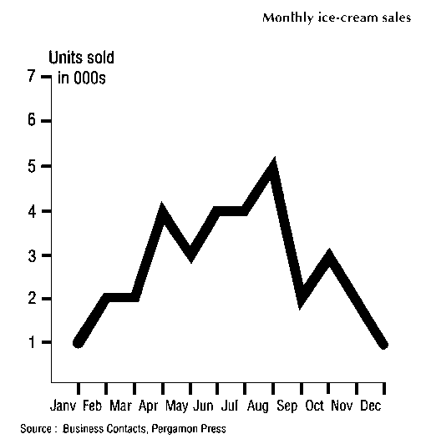

♦♦♦The End.♦ ♦♦